Putting out a batter

A batter can be put out in the following ways:
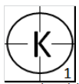 | - Strikeout [OBR 5.09(a)(2)]. A strikeout occurs when “A third strike is legally caught by the catcher; ‘Legally caught’ means in the catcher’s glove before the ball touches the ground”. This is the most common form of strikeout, and should be recorded with the letter “K” inside the circle that indicates an out.

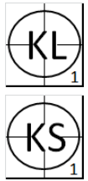 | To know whether the batter made a swing to the third strike, or the third strike was called by the umpire (and the batter was "looking"), we add another letter to the "K" to explain this. Therefore we normally don't write just "K" but always "KL" or "KS".  When a batter strikes out, the putout should be credited  exclusively to the catcher.
If the catcher, after having dropped the third strike, recovers the ball and tags the batter-runner before he reaches first base, the symbol will beKS2 or KL2.
Besides the putout for the catcher, the strikeout must be recorded in the appropriate boxes for the batter who got struck out, as well as in the boxes in the pitcher section to the appropriate pitcher.
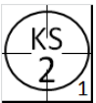 | As the strikeout is always credited as a putout to the catcher, the annotation “K.2” is incorrect, unless the third strike is not caught by the catcher and he has to tag the batter to get the out.
NOTE: If the umpire calls “Strike 3”, which occurs when the third strike is not caught or held by the catcher with first base free, or occupied but with two men out, a strikeout is credited to the pitcher and at the same time charged against the batter, even if the batter should become a runner or is put out.
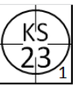 | If first base is free, or there are already two out, the batter may try to advance. If the catcher recovers the ball and assists the first baseman by anticipating the arrival of the batter-runner, the putout will be recorded with the notation KS23”or “KL23”, crediting an assist to the catcher, a putout to the first baseman and a strikeout to the pitcher.
In order to be able to tell instantly how many strikeouts have been made by each pitcher, they are numbered consecutively, below and to the right of the putout circle. Each time a pitcher is replaced the numbering is restarted.
NB: A strikeout should not be confused with a putout proper. Each time a strikeout is made, independently of the putout, it should be credited to the pitcher who pitched it. Only if the strikeout is followed by the batter-runner being put out should an out be credited to the defense. In the most common form of strikeout, recorded as “KS1” or “KL1” in the first example, a strikeout is credited to the pitcher and to the batter and a putout to the catcher.
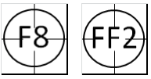 | - Out by fly ball (a batted ball that goes high in the air in flight) [OBR 5.09(a)(1)]. A batter is declared out when “His fair or foul fly ball (other than a foul tip) is legally caught by a fielder.” This is recorded with “F.” (the dot represents the fielder who made the putout) if the ball is caught in fair territory, or “FF.” if the ball is caught in foul territory. The base runners may try to advance by leaving their bases after the ball has been touched by a fielder. The examples given show a fly ball caught by the center fielder and a foul fly caught by the catcher.

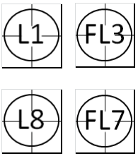 | If a line drive (a batted ball that goes sharp and direct from the bat to a fielder without touching the ground) is caught by a fielder, the symbol “L.” (the dot represents the fielder who made the putout) is used if the ball is caught in fair territory, or “FL.” if in foul territory. The examples given show a line drive caught on the fly by the pitcher and the center fielder in fair territory as well as a line drive caught on the fly in foul territory by the first baseman and the left fielder (if a ball is hit into the outfield and does not describe a high trajectory and is taken on the fly by an outfielder, it is not a fly ball and the out must always be registered with an L. or FL. if on foul territory).

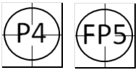 | A pop fly (or pop-up) is a specific type of fly ball that goes very high while not traveling very far laterally; from the perspective of the fielder, pop-ups seem to come straight down. When a pop fly is caught by a fielder, the symbol “P.” (the dot represents the fielder who made the putout) is used if the ball is caught in fair territory or “FP." if caught in foul territory. The examples given show a pop fly caught by the second baseman in fair territory and a pop fly caught by the third baseman in foul territory.

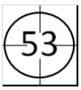 | - Out by ground ball (A batted ball that rolls or bounces close to the ground) [OBR 5.09(a)(10)]. A batter is out when “After a third strike or after he hits a fair ball, he or first base is tagged before he touches first base.” In the example, after it is hit the ball is caught by the third baseman, who assists the first baseman retiring the batter-runner.

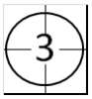 | When a ground ball is caught by the first baseman, who tags the base or batter-runner before he succeeds in reaching the base, an unassisted putout is recorded, as noted in the example.

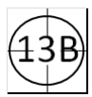 | When the batter bunts (batted ball not swung at, but intentionally met with the bat and tapped slowly within the infield) the ball and is put out, and the bunt cannot be considered a sacrifice bunt, we add the letter "B" to know afterwards that it was a bunt. The example shows a bunt fielded by the pitcher who throws to the first baseman for the putout

